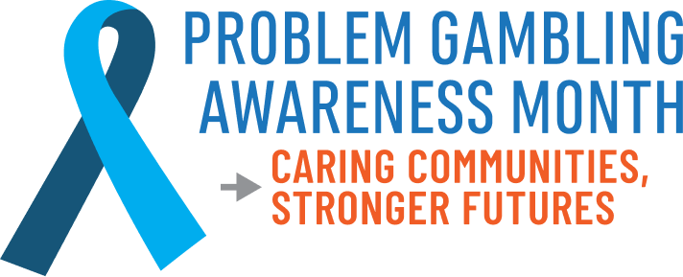
Problem Gambling Awareness Month
Proclamation Sample Language
WHEREAS, the National Council on Problem Gambling (and any additional state/local sponsors) has designated March 2026 as Problem Gambling Awareness Month;
WHEREAS, problem gambling is a public health issue affecting millions of Americans of all ages, races, and ethnic backgrounds;
WHEREAS, problem gambling has a significant societal and economic cost for individuals, families, businesses and communities;
WHEREAS, problem gambling is treatable, and treatment is effective in minimizing this harm to individuals, communities and society as a whole;
WHEREAS, numerous individuals, professionals and organizations have dedicated their efforts to the education of the public about problem gambling and the availability and effectiveness of treatment;
WHEREAS, the National Council on Problem Gambling, (list additional participating organizations) invite all residents of (city/state) to participate in Problem Gambling Awareness Month.
THEREFORE, I, (name and title of official), do hereby proclaim the month of March 2026 as Problem Gambling Awareness Month in (city/state) and encourage all citizens to support the National Council on Problem Gambling (and any additional state/local sponsors) in their efforts to mitigate gambling-related harm nationwide.

Signature: ________________________________________________
Name and Title: ___________________________________________
Date: ___________________________________________________

