Your Logo Here | 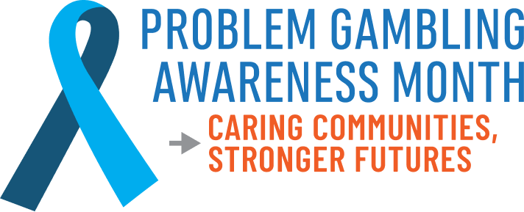
FOR IMMEDIATE RELEASE
Date of Release
Contact:
Local Point of Contact
Local POC Phone Number
Local POC Email Address
March is Problem Gambling
Awareness Month
CITY, STATE — (Organization Name), in partnership with the National Council on Problem Gambling (NCPG), recognizes March as Problem Gambling Awareness Month (PGAM). This year’s theme, “Caring Communities, Stronger Futures,” emphasizes the importance of a community-driven approach to problem gambling awareness and support. The annual campaign aims to increase public awareness of problem gambling and the availability of prevention, treatment, and recovery services, as well as encourage healthcare providers to screen for problem gambling and connect individuals to appropriate support.
Problem gambling, defined as gambling behaviors that disrupt or damage personal, family, or professional lives, affects millions of Americans. In the U.S. 2.5 million adults (1%) are estimated to meet the criteria for a severe gambling problem in a given year. Another 5–8 million (2–3%) are considered to have mild or moderate gambling problems. Additionally, in the past year, approximately 20 million American adults reported experiencing at least one indicator of problematic gambling behavior.
(Insert a quote from a local leader or spokesperson.)
Suggested quote framework:
“Our community isn’t defined by its challenges; it is defined by how we respond. When we come together with compassion, understanding, and proactive solutions, we can effectively address gambling-related harm and help shape stronger futures.” — Name, Title
A Community-Driven Approach to Awareness and Support
Throughout March, (Organization Name) will lead efforts focused on increasing public understanding of problem gambling and ensuring individuals are aware of the available prevention, education, treatment, and recovery services in their community. Activities will include:
- (PGAM Activity #1) – e.g., Community conversations, education workshops, or local listening sessions
- (PGAM Activity #2) – e.g., Problem Gambling Screening Day, resource fairs, or awareness events
- (PGAM Activity #3) – e.g., Social media campaigns, storytelling projects, or webinars featuring local experts
These efforts reflect a simple truth: when community comes together — friends, families, educators, healthcare providers, local partners, and policymakers — silence is replaced with support, and isolation is replaced with connection. To learn more about problem gambling, please visit NCPGambling.org/FAQs
(Organization Name) encourages local media, partners, and residents to join the effort by sharing resources, uplifting stories of those in recovery, and helping connect people to available support.
If you or someone you know is struggling with a gambling problem, the National Problem Gambling HelplineTM offers free, confidential support 24/7:
Call 1-800-MY-RESET
Text 800GAM
Chat at www.NCPGambling.org/chat.

