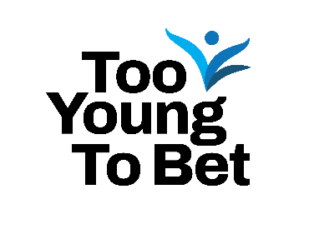 | (Your Logo Here)
(Organization name) Joins 2025 Too Young to Bet Campaign to Raise Awareness of Youth Gambling Risks

FOR IMMEDIATE RELEASE
(Date of Press Release)

CONTACT:
(Contact Name)
(Contact Email)
(Contact Phone Number)

(City, State) – The (Organization Name) today announced its commitment as a (Participation Level or remove if Non-Lottery participant) participant of the 2025 Too Young to Bet Campaign, a newly-introduced participation option for the annual Gift Responsibly Campaign.

(Organization Name) joins lotteries and community organizations across North America and around the world to raise awareness about the risks of underage gambling. The campaign is organized by the National Council on Problem Gambling (NCPG) and supported by the North American Association of State and Provincial Lotteries (NASPL).

Research shows that the earlier a child is exposed to or participates in gambling, the greater their risk of developing a gambling problem either immediately or later in life. Many adults may introduce gambling activities, such as sports betting or scratch-off tickets, without understanding the potential risks.

(Quote from organizational representative about why your organization joined the campaign)

(Organization Name) has signed on to the 2025 Too Young to Bet Campaign as a (Participation Level or remove if Non-Lottery participant) participant. During the months of November and December, (Organization Name) will work to promote awareness about the risks of underage gambling by (list campaign activities i.e. public service announcements, social media posts, etc.)

“Youth gambling is a growing risk that too often goes overlooked. The Too Young to Bet Campaign plays a vital role in helping families and communities understand the importance of keeping gambling products out of kids’ hands,” said Derek Longmeier, President of NCPG’s Board of Directors. “We’re grateful to (Organization Name) for joining this effort and working to expand education and awareness to protect young people from gambling-related harm.”

(Organization to add more about its involvement with NCPG Affiliate and/or other community organizations or statement about organization’s overall commitment to social responsibility, responsible gambling, and addressing problem gambling.)

About (Organization Name)
(Your boilerplate)

About the National Council on Problem Gambling
The National Council on Problem Gambling (NCPG) is neutral on legalized gambling. Based in Washington DC, NCPG is the only national nonprofit organization that seeks to minimize the economic and social costs associated with gambling addiction. If you or someone you know may have a gambling problem, contact the National Problem Gambling Helpline™, which offers hope and help without stigma or shame. Call 1-800-522-4700, text 800GAM, or visit www.ncpgambling.org/chat. Help is available 24/7 – it is free and confidential.

